

American International University-Bangladesh (AIUB)
Department of Computer Science Faculty of Science & Technology (FST)
PROJECT TITLE
Society Problem Reporter and Analyzer
Submitted By Group 7
Semester-->Summer-25-26 |  | Section:T
SL | Student Name | Student ID
29 | 24-58655-2 | Sheikh Ahnaful Islam
31 | 24-58796-2 | Ayon Chowdhury
22 | 24-58220-2 | MD. Mezbah-Ul-Hossain Rahat
4 | 23-53306-3 | Md Rashed Musharof
3 | 23-52565-2 | Sabit Haan

3. SOFTWARE REQUIREMENTS SPECIFICATION (SRS) / PRD

3.1 Scopes and Features (Functional)
The Community Problem Reporting & Priority Analyzer is a web application that enables citizens to report local infrastructure issues, vote on existing reports, and track resolution progress. Authorities can view prioritized problem lists and update statuses. The platform serves three access roles: Citizen, Authority, and Admin.

Feature ID | Feature Name | -Features / Screens Sub
F1 | User Authentication | Sign up | Sign in | Forgot Password
F2 | Problem Reporting System | Report Problem | View Submitted Problems
F3 | Citizen Voting System | Vote on Problem | View Vote Count
F4 | Priority Analyzer | Calculate Priority Score | Rank Problems by Priority | Display High Priority Problems
F5 | Authority Dashboard | View All Reported Problems | Update Problem Status
F6 | Problem Status Tracking | View Problem Status Details | Receive Status Updates
F7 | User Profile Management | View Profile | Edit Profile

Access Roles
- Citizen (User) – Reports problems, votes, tracks status, manages profile.
- Authority – Views all reports, updates problem status, accesses priority dashboard.
- Admin – Manages users, monitors system activity, oversees all data.

3.2User Story Table-
User | Wants To | So That

Citizen | As a Citizen, I want to register an account with my name, email, phone number, and password | So that I can access the Community Problem Reporter platform.

Citizen | As a Citizen, I want to report a local problem by providing a title, description, category, severity, image, and location | So that the relevant authorities are informed about the issue.

Citizen | As a Citizen, I want to view a list of my submitted reports | So that I can track the problems I have reported.

Citizen | As a Citizen, I want to up-vote problems reported by others | So that urgent community issues receive higher priority.

Citizen | As a Citizen, I want to view the details and status history of my reported problems | So that I can monitor the progress of their resolution.

Citizen | As a Citizen, I want to receive notifications whenever the status of my report changes | So that I stay informed about updates.

Citizen | As a Citizen, I want to sign in securely using my email and password | So that I can report and track community problems.

Citizen | As a Citizen, I want to reset my password if I forget it | So that I can regain access to my account securely.

Citizen | As an Citizen, I want to view the vote count on each reported problem | So that I know how many people are affected by the issue.

Citizen | As anCitizen, I want to view my profile information, including my name, email, phone number, and total reports submitted | So that I can monitor my account activity.

Citizen | As an Citizen, I want to edit my profile information | So that my account details remain up to date.

Authority | As an Authority, I want to view problems ranked by priority score | So that I can address the most critical issues first.

Authority | As an Authority, I want to view all reported problems with their complete details | So that I can manage community issues efficiently.

Authority | As an Authority, I want to update the status of reported problems (Submitted, Under Review, In Progress, Resolved) | So that citizens remain informed about the resolution process.

Admin | As an Admin, I want to manage user accounts | So that the platform remains secure and well organized.

Admin | As an Admin, I want to monitor problem reports and overall system activity | So that I can ensure smooth and reliable platform operation.

System | As the System, I want to automatically calculate a priority score using severity, votes, and report time | So that authorities can focus on resolving the most critical community problems first.

Figma
Role: Admin
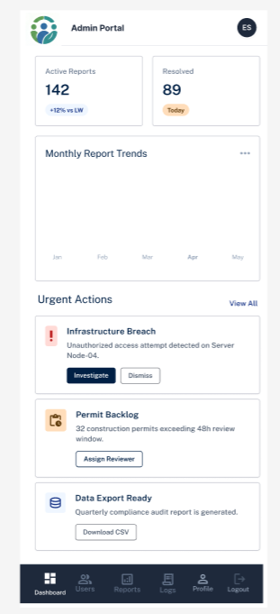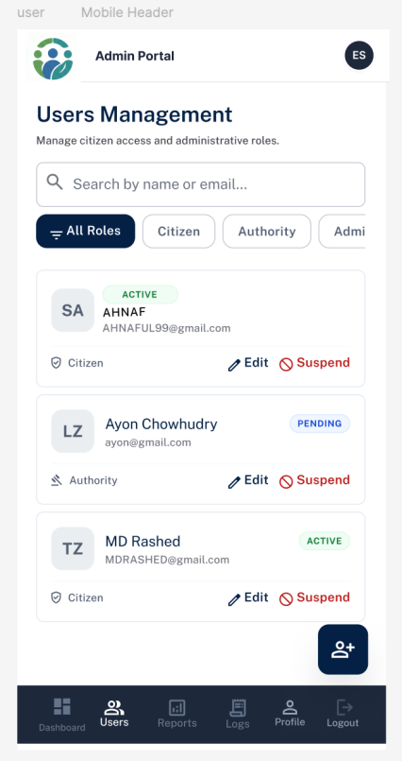
Figure : Admin Dashboard Figure: Manage Users
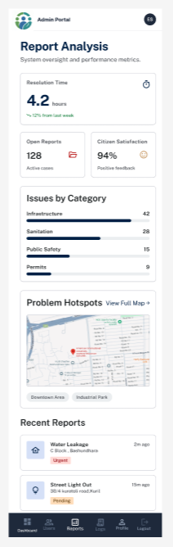 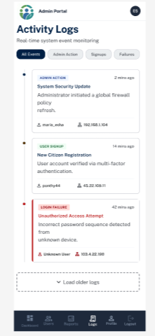 Figure: Report Analysis Figure: Activity Logs

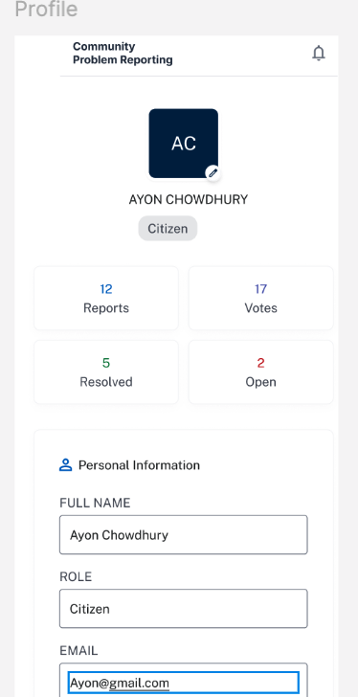
Figure: Profile

